> This document provides concise evidence that the data collected for analysis does not exhibit any trend.

### Patterns in 2 soils (2 measurement each for Masado and Rakishitudo) for 4 components at 7 overtones = 2x2x4x7 = 112 patterns

# Overtones Analysed

* [52, 103, 155, 206, 257, 310, 360]
* ±6 Hz at each overtone

This graph below shows information from Masado and Rekishitudo for compaction 1 through 5 for all components (ACC_X, ACC_Y, ACC_X, AUDIO). These are the patterns observed, around overtones frequency (of occurrence) higher than 3. As it is clearly visible, there is no dominant pattern. The patterns with the highest frequencies are almost uniformly distributed from all permutations between 12345 and 54321.

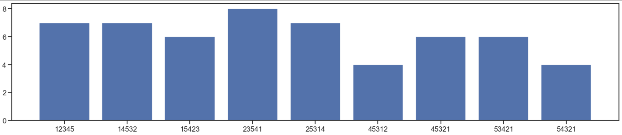

Adding to that, there are also a number of other patterns with frequency lower than 4. This is the graph of all the patterns observed.

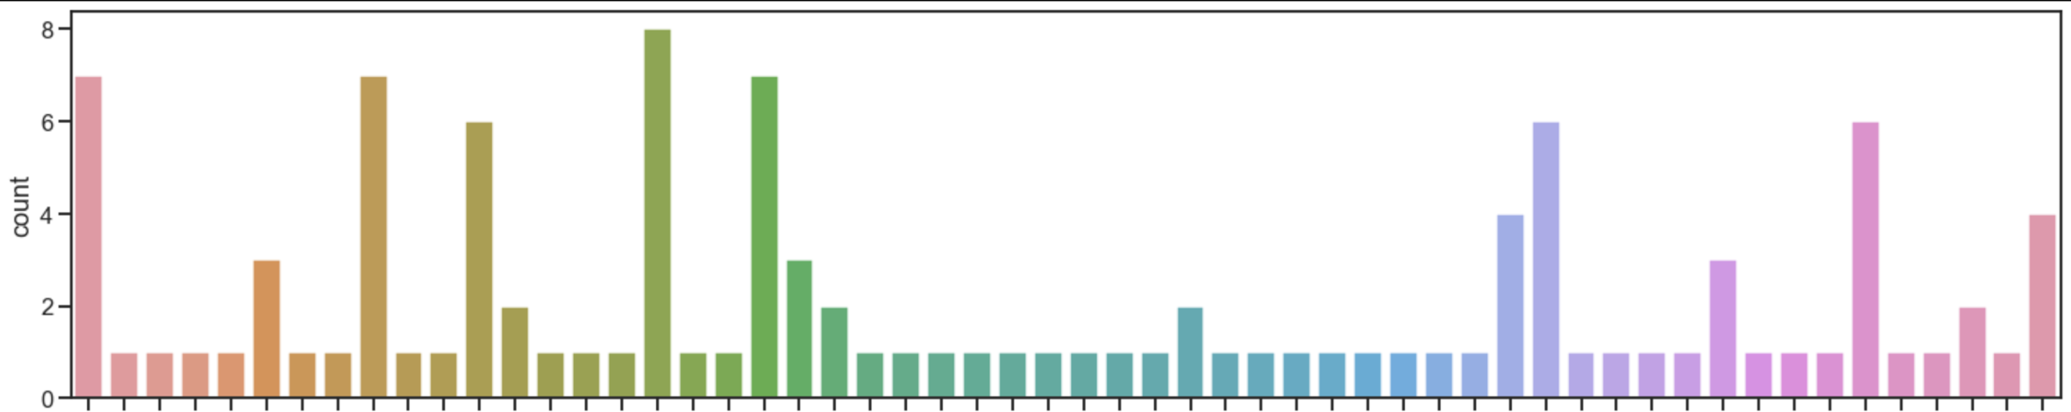

One of the most extreme graphs is for AUDIO. If I compare patterns in audio data for the 3 soils (2 observations each), the patterns are all unique! None repeating.

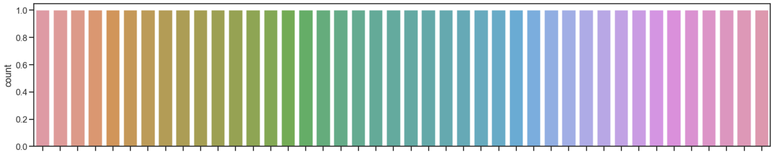

MASADO (FEB 3)

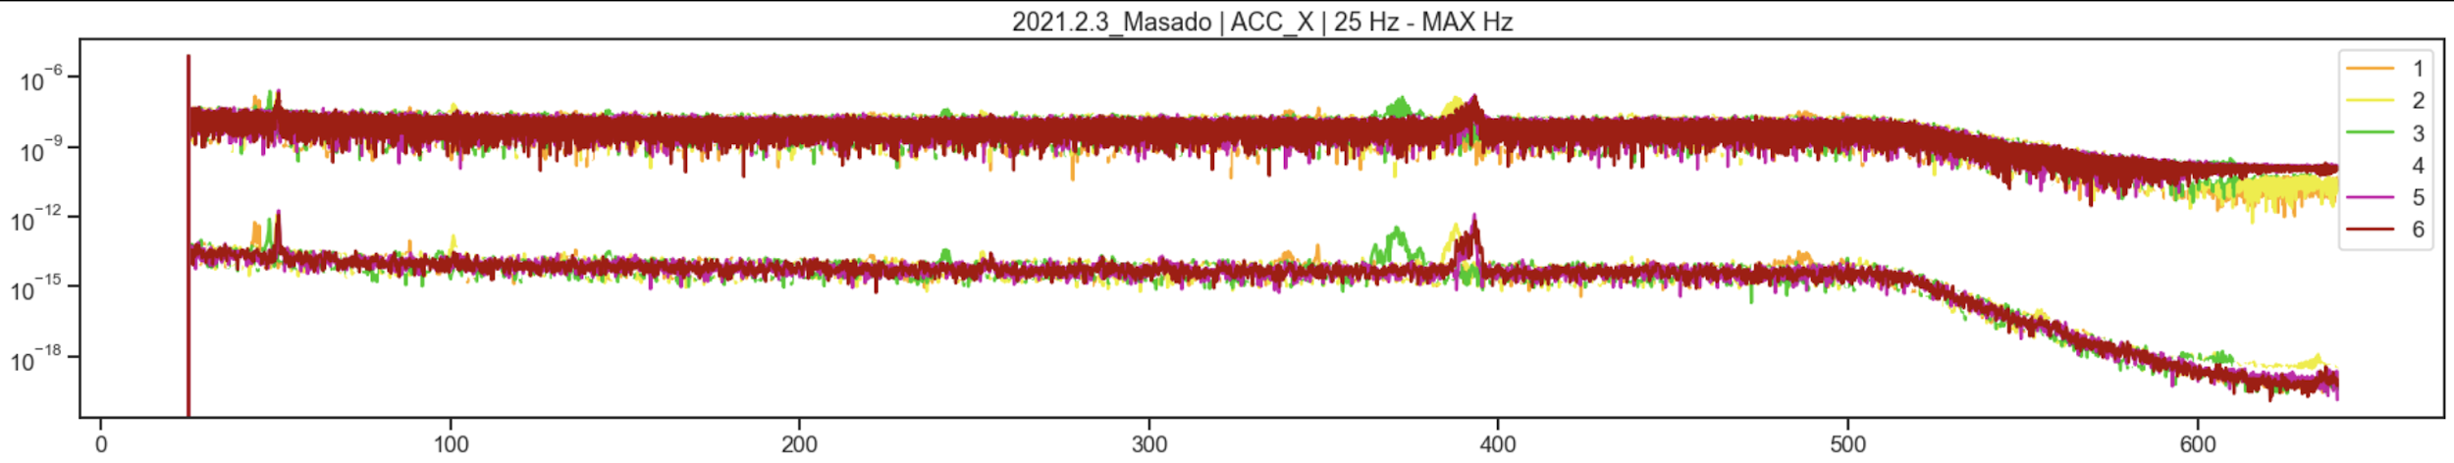

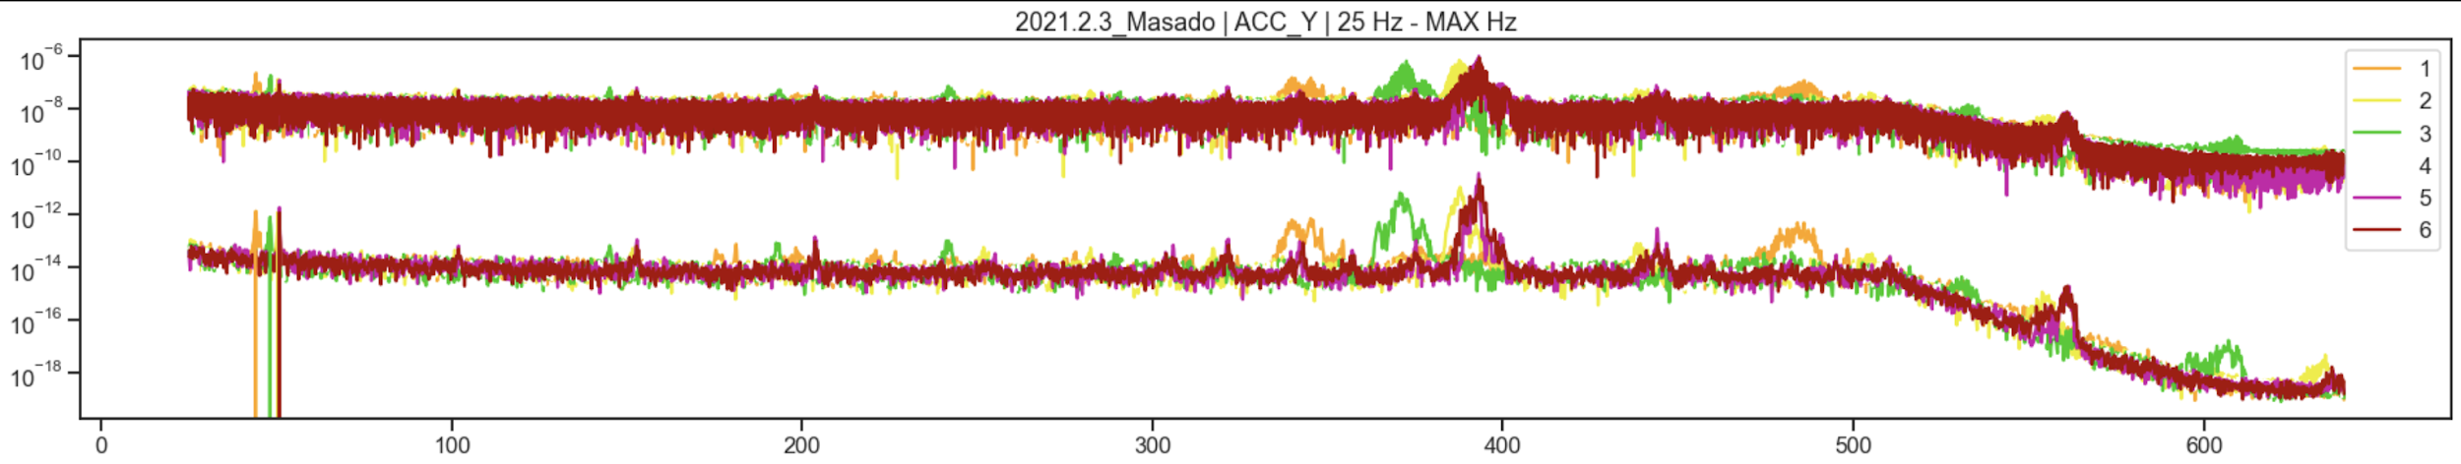

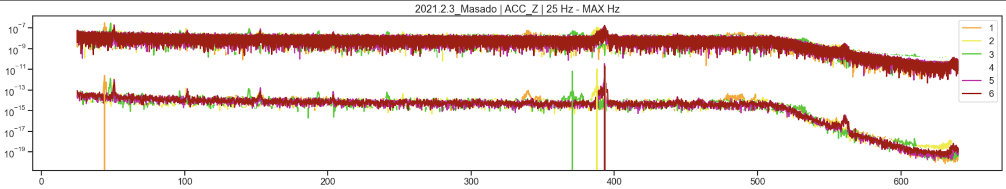

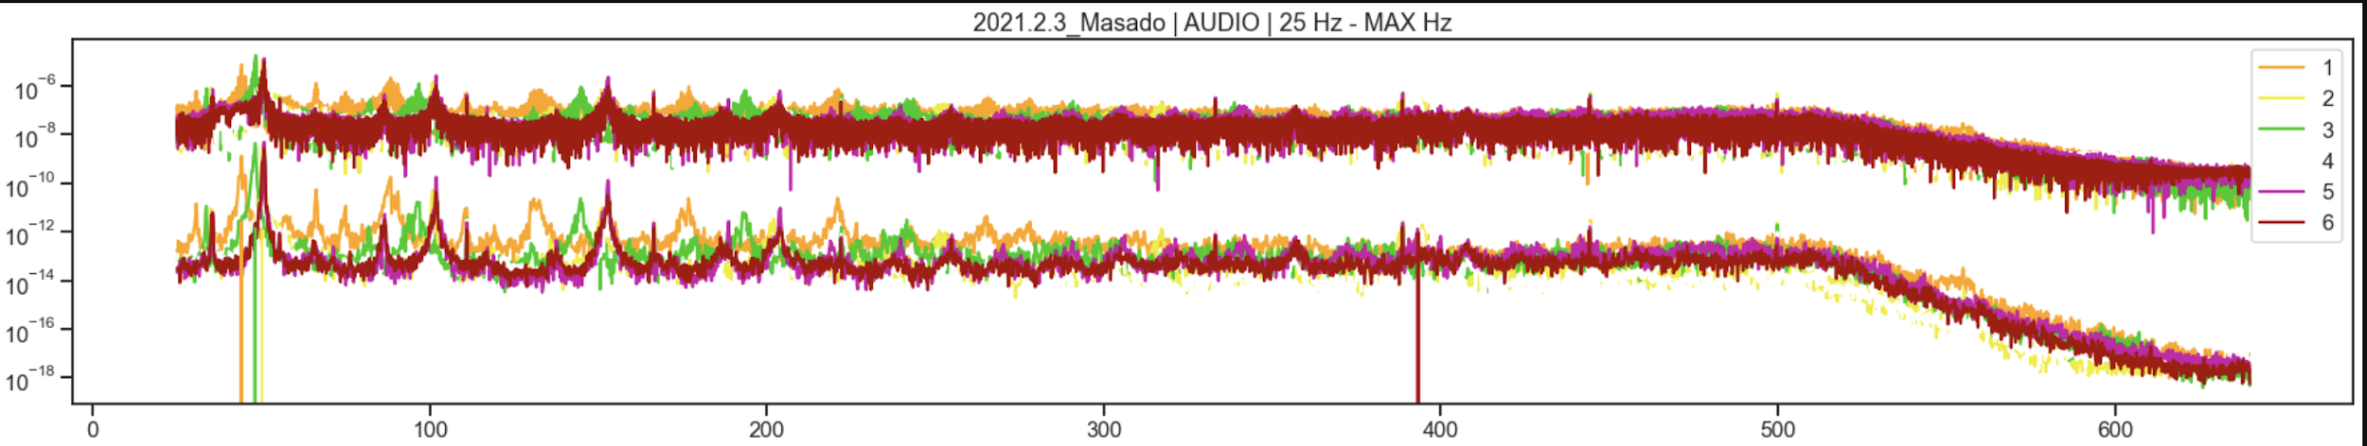

NENSEIDO (FEB 4)

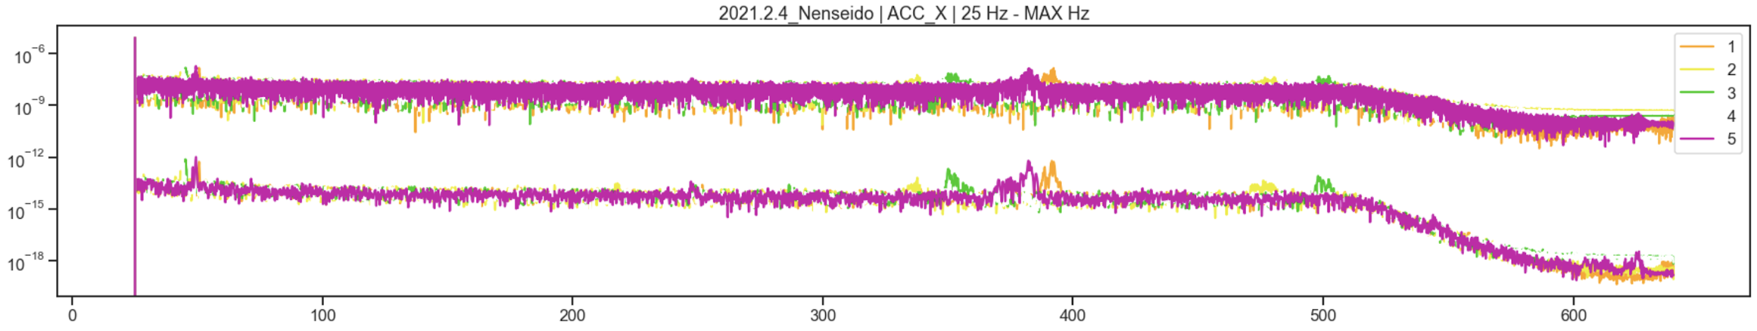

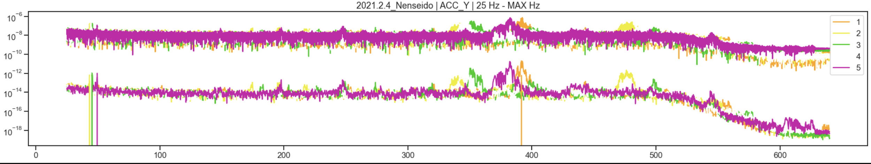

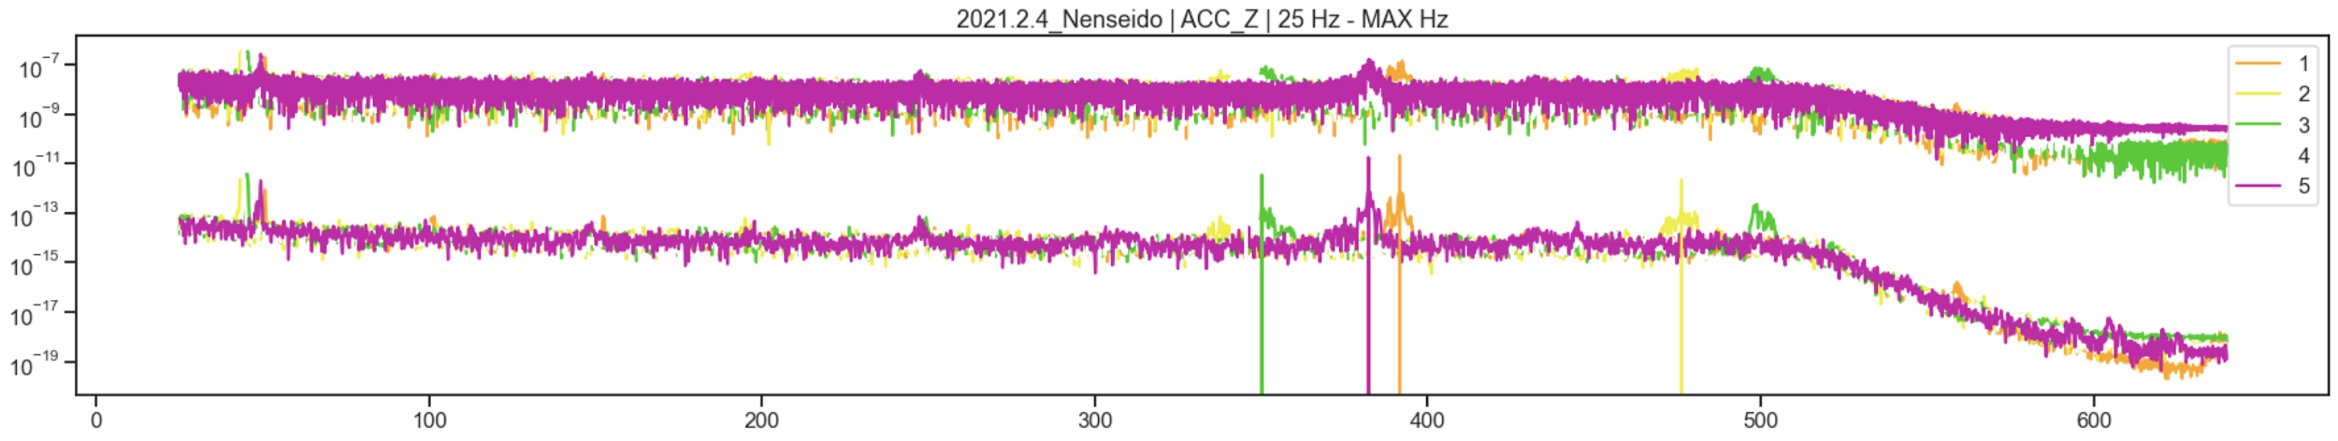

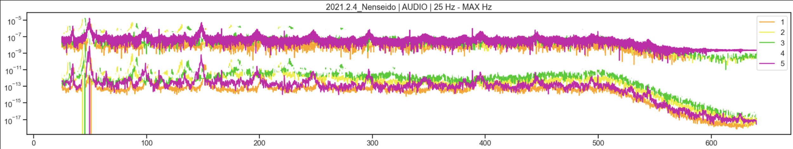

REKISHITUDO (FEB 5)

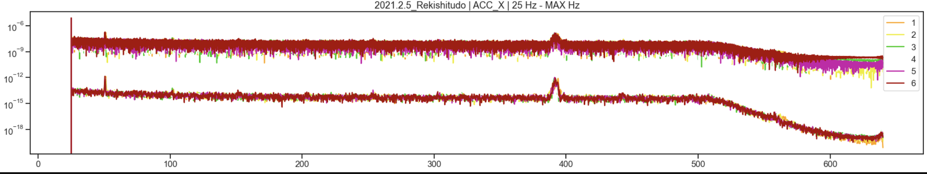

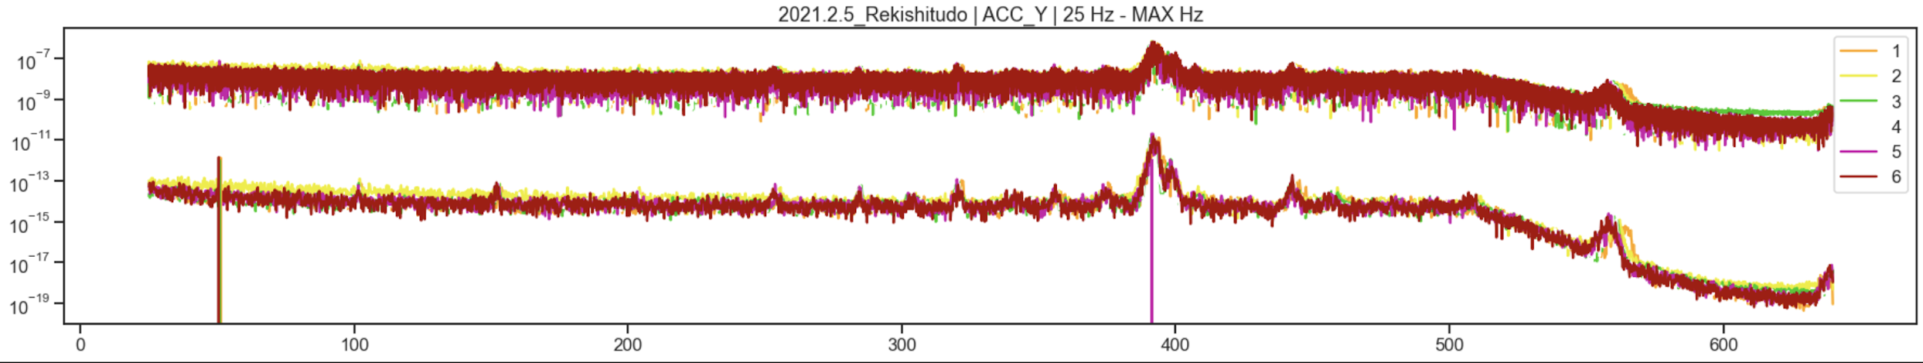

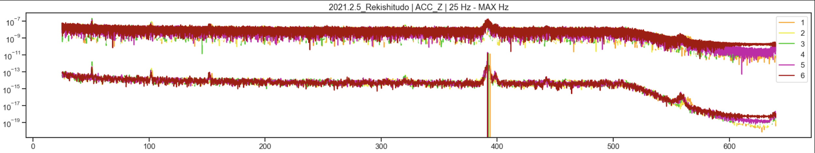

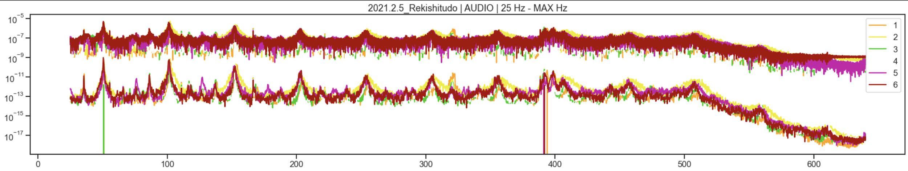

MASADO (FEB 5)

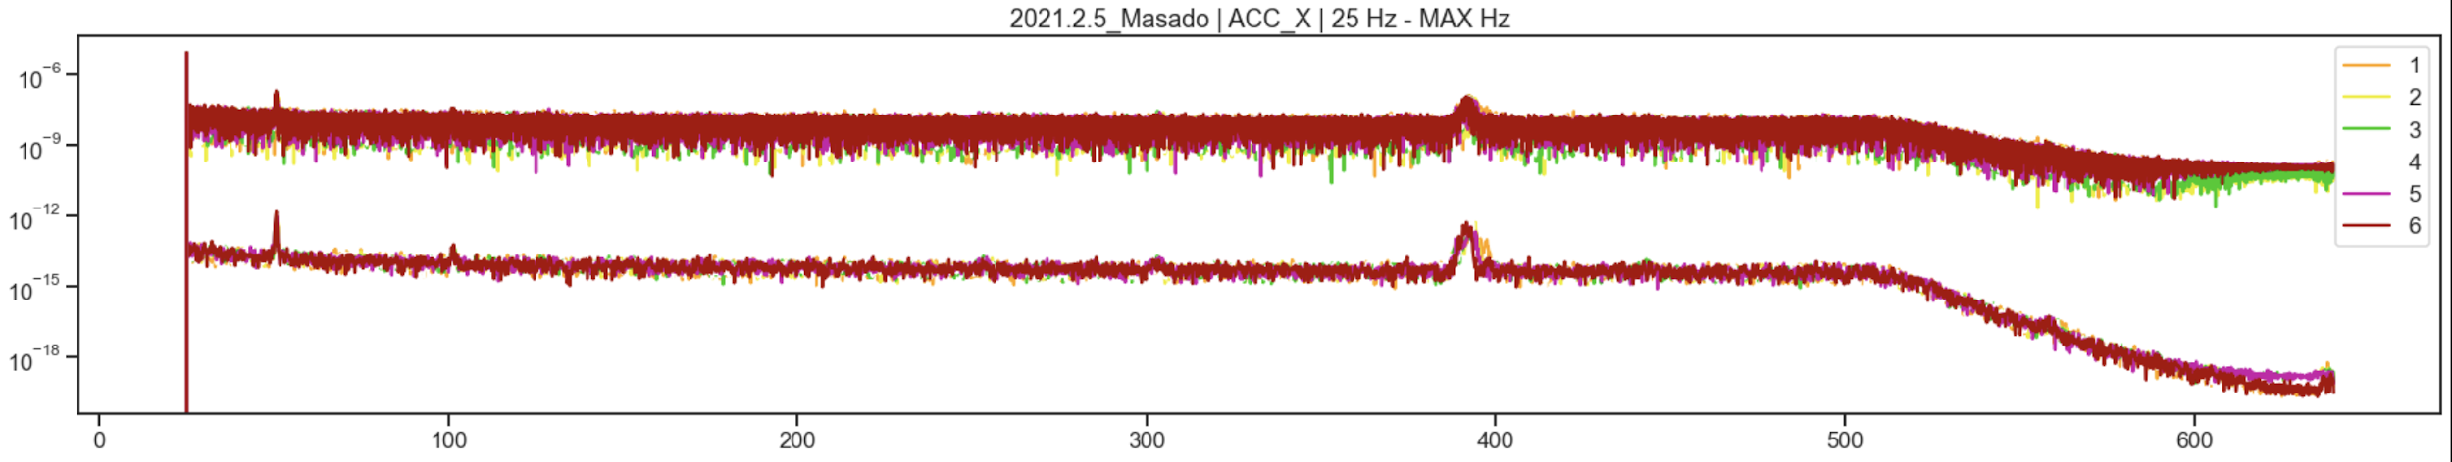

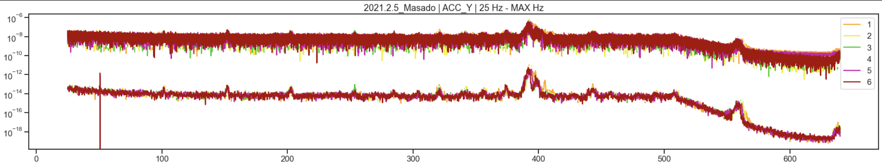

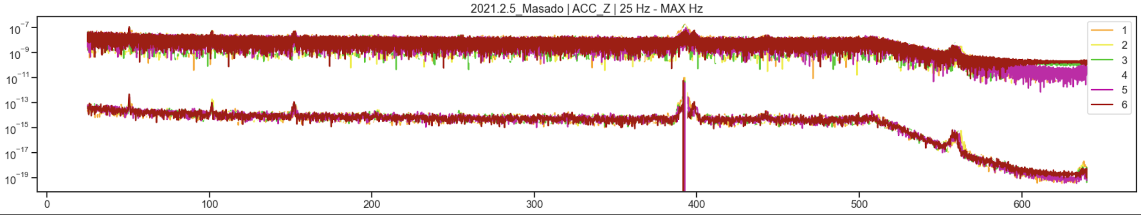

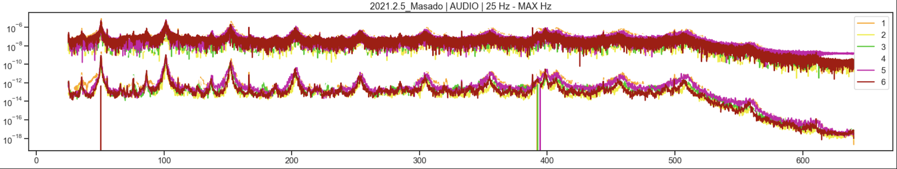

NENSEIDO (FEB 6)

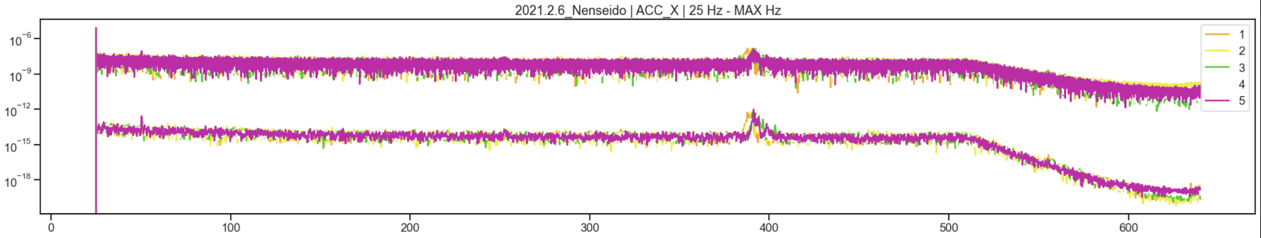

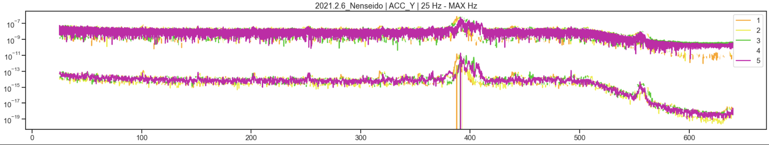

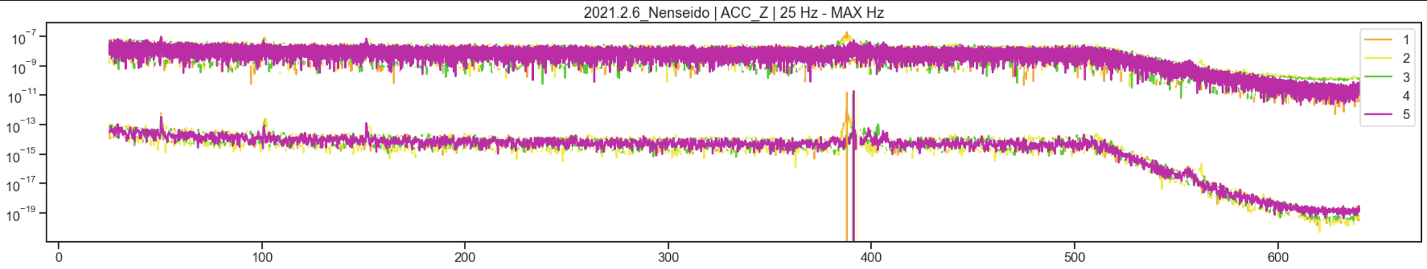

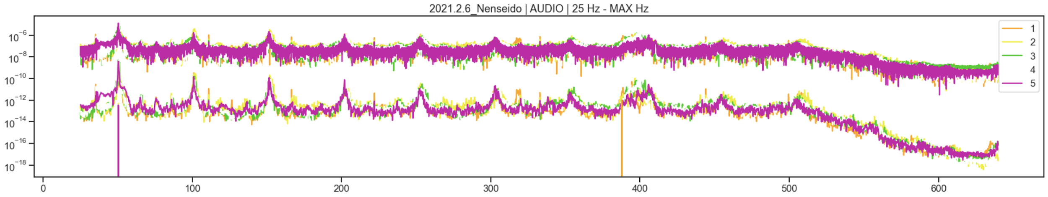

REKISHITUDO (FEB 4)

